**Online Banking System Project**

**PROJECT NAME : KRASV BANK**

**TEAM NAME : TECHNO TRIBE**

**GROUP MEMBERS :**

1. **Kaushal Kumar**
2. **Rohan Chavan**
3. **Arpit Kumar**
4. **Sharayu Nalawade**
5. **Venkat Chakkani**

**1. Project Overview**

1.1 Introduction

1.2 Purpose

1.3 Scope

**2. Objectives**

2.1 Primary Objectives

2.2 Secondary Objectives

**3. Features**

3.1 User Registration and Login

3.2 Account Management

3.3 Fund Transfers

3.4 Bill Payments

3.5 Transaction History

3.6 Customer Support

3.7 Security Features

**4. Technical Requirements**

4.1 Hardware Requirements

4.2 Software Requirements

4.3 Network Requirements

**5. Flow Chart**

5.1 Flow chart image

**6. Entity Relationship Diagram**

6.1 ER Diagram Image

**7. Testing and Quality Assurance**

7.1 Testing Plan

7.2 Types of Testing

**8. Deployment Plan**

8.1 Steps for Deployment

8.2 Post-Deployment Activities

**9. Maintenance and Support**

9.1 Maintenance Plan

9.2 Support Plan

**10. Conclusion**

10.1 Summary

10.2 Future Enhancements

**Project Overview**

**Introduction**

The Online Banking Project aims to develop a comprehensive online banking system to provide users with a secure and efficient way to manage their finances. This system will offer a range of features including account management, fund transfers, bill payments, and more.

**Purpose**

The purpose of this project is to create an online platform that allows users to perform banking activities from the comfort of their homes or on the go, thus enhancing customer convenience and satisfaction.

**Scope**

The scope of this project includes the development of a user-friendly web application that supports various banking functions, integration with backend systems, and ensuring robust security measures to protect user data.

**Objectives**

1. **Primary Objectives**

* Develop a secure online banking platform.
* Ensure user-friendly interface and experience.
* Integrate essential banking features.

1. **Secondary Objectives**

* Implement advanced security measures.
* Provide responsive customer support.
* Ensure scalability for future enhancements.

**Features**

1. **User Registration and Login**

* Secure user registration process.
* Multi-factor authentication for login.

1. **Account Management**

* View account details and balance.
* Update personal information.

1. **Fund Transfers**

* Transfer funds between own accounts.
* Transfer funds to other bank accounts.

1. **Transaction History**

* View detailed transaction history.
* Download transaction statements.

1. **Customer Support**

* Email and phone support.

1. **Security Features**

* Data encryption.
* Regular security audits.

Technical Requirements

1. **Hardware Requirements**

* Servers with high processing power.
* Reliable storage solutions.

1. **Software Requirements**

* Account Management Service: Spring Boot, Spring Data JPA, MySQL, Docker, Kubernetes
* Transaction Service: Spring Boot, Spring Cloud, Redis (for caching), MySQL, Docker, Kubernetes
* Fund Transfer Service: Spring Boot, Spring Cloud, RabbitMQ, Docker, Kubernetes
* Reporting Service: Spring Boot, Spring Data JPA, MongoDB, Docker, Kubernetes
* Frontend: Node.js, React or Angular
* Deployment: AWS (EKS, RDS, S3)

1. **Network Requirements**

* High-speed internet connection.
* Secure network infrastructure.

**Flow Chart**

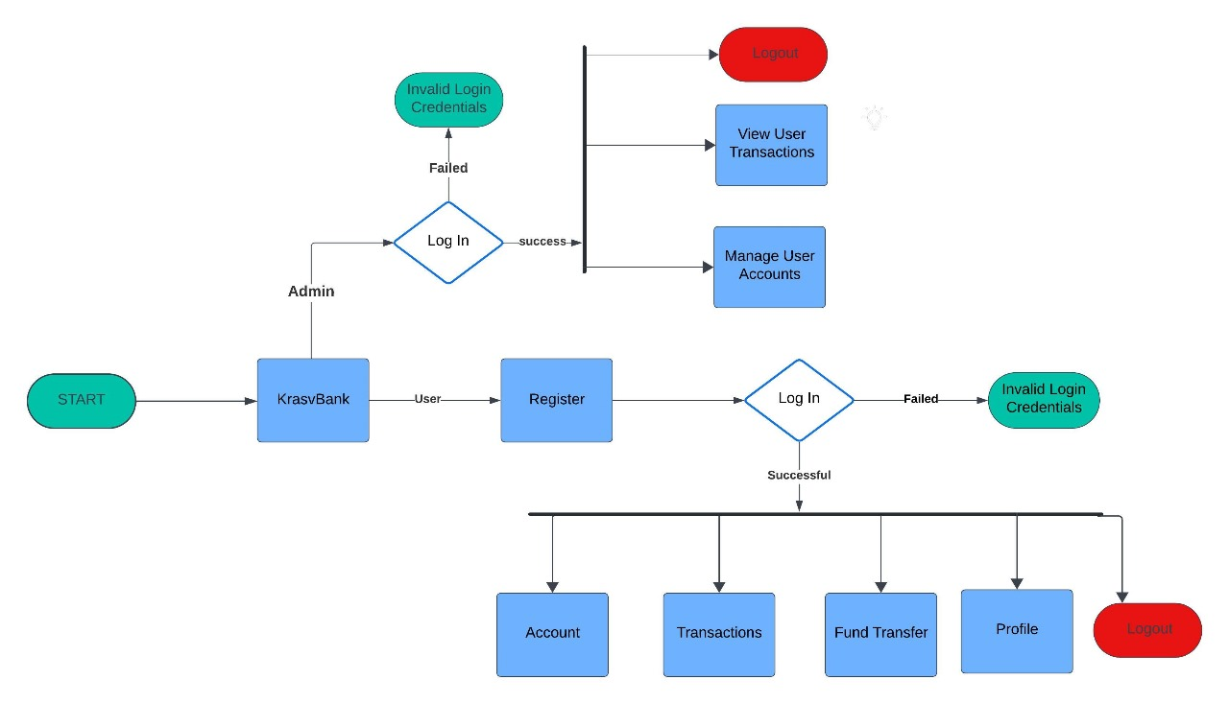

**Entity Relationship Diagram**

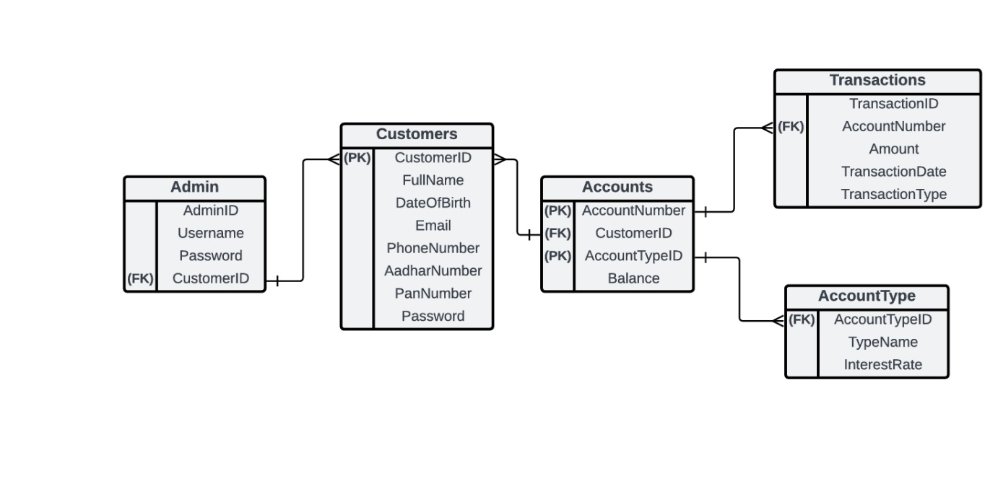

**Testing and Quality Assurance**

1. **Testing Plan**

* Unit testing.
* Integration testing.
* User acceptance testing.

1. **Types of Testing**

* Functional testing.
* Performance testing.
* Security testing.

**Deployment Plan**

1. **Steps for Deployment**

* Finalize and test deployment scripts.
* Set up production environment.
* Deploy the application.

1. **Post-Deployment Activities**

* Monitor system performance.
* Address any post-deployment issues.
* Gather user feedback for improvements.

**Maintenance and Support**

1. **Maintenance Plan**

* Regular system updates.
* Bug fixes and improvements.

1. **Support Plan**

* 24/7 customer support.
* Regular training sessions for support staff.

**Conclusion**

**Summary**

The Online Banking Project aims to provide a secure, user-friendly platform for banking activities, enhancing customer experience and operational efficiency.

**Future Enhancements**

* Mobile application development.
* Integration with more third-party services.